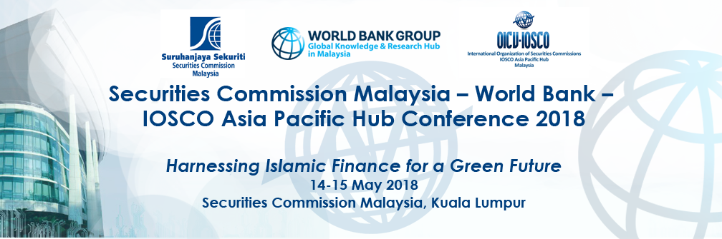

Draft Programme

Day 1: Tuesday, 14 May 2018
9.00 am – 5.15 pm

Agenda
SESSION 1: OVERVIEW OF ISLAMIC GREEN FINANCE DEVELOPMENT

The session will set the stage by providing an overview of green finance instruments currently in use around the world (e.g. green funds, bonds, equities), the global trend of green bond markets and demand for large infrastructure green projects. This will be followed by a discussion about the links between Islamic finance and green finance as well as innovative Islamic instruments as green sukuk.
SESSION 2: TOWARDS AN ENABLING ENVIRONMENT FOR ISLAMIC GREEN FINANCE: DEVELOPING GUIDELINES & STANDARDS

This session will focus on the enabling environment for Islamic green finance, including the role of international institutions and regulatory authorities in establishing the required ecosystem, particularly on the guidelines/framework for issuing green financing projects. This session will also discuss how international institutions can build a platform for cooperation between players involved in green financing.

SESSION 3: DEVELOPING A SUCCESSFUL GREEN SUKUK PROGRAM: OPPORTUNITIES AND CHALLENGES

This session will assess the current state of the green sukuk market (sovereign and corporate), the potential for growth and the challenges that need to be addressed in order to fulfil its potential. Second opinion providers play a significant role in preserving the credibility of this asset class. The speakers will review the current practice in assessing the ‘greenness’ of the project and the Shariah aspects of the green sukuk.

SESSION 4: CASE STUDIES ON GREEN SUKUK

This session will present several case studies on how sukuk has been used to support certified green projects. It will highlight key aspects, facilitating factors, challenges faced and solutions provided, and experiences in using sukuk.

Day 2: Wednesday, 15 May 2018
9.00 am – 1.30 pm

Agenda
SESSION 5 – A DIALOGUE ON SUSTAINABLE FINANCE
SESSION 6 - ACCELERATING GROWTH IN THE GREEN SECTOR: POLICY AND INCENTIVES FOR GREEN PROJECTS

This session will focus on initiatives to support green projects. Speakers across the globe will share approaches and experiences in the design and use of different policies and incentives.

SESSION 7 – ENGAGING THE PRIVATE SECTOR: ROLE OF INSTITUTIONAL INVESTORS IN ISLAMIC GREEN FINANCE

A panel comprising representatives of pension funds and sovereign wealth funds will discuss how these entities can support the growth and development of green finance.

SESSION 8 – PROSPECTS OF ISLAMIC GREEN FINANCE

This session will review the development and prospects of green Islamic finance. Experts will share their perspectives on potential and existing products and platforms that could apply green Islamic finance, creating new opportunities to this asset class.

