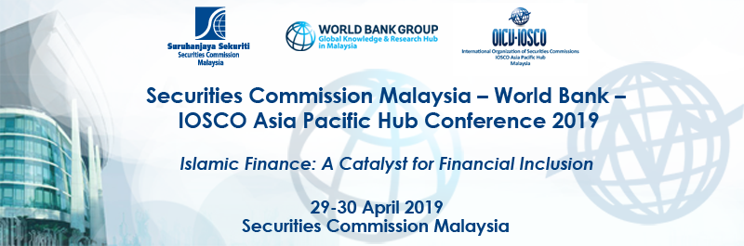

Registration Form
VENUE: CONFERENCE HALL, SECURITIES COMMISSION MALAYSIA,
3 PERSIARAN BUKIT KIARA, 50490 KUALA LUMPUR
PERSONAL INFORMATION
Mr / Ms | Last name: |  | First name:
Preferred Name (for badge):
Job Title:
Organisation:
Address:
Postal Code:
Country:
Phone: |  | Fax:
E-Mail:
Dietary restrictions:
Please return the completed form to Azfalyna Aziz at
Azfalyna@iosco.org.my
Tel: + 603 6204 8061; Fax: +603 6204 8089
no later than 12 April 2019

